Maurice Farr SDEV-140 GUI Tkinter App Final Project, Part 1 Due Date: 12/9/2024

**Source Code of All files (.py):**

# header information

"""

author: Maurice Farr

date: 12/9/2024

assignment: SDEV-140 GUI Tkinter App Final Project, Part 1

purpose: We need to create a GUI Tkinter application that monitors individuals blood glucose level by inputting that inside the app. Within this app, a separate file called

Project Functions.py, will be needed with the rest of the necessary functions to successfully run this application.

"""

#FarrMauriceFinalProject(Maurice Farr).py

**#Source Code of All files (.py):**

from tkinter import*

from tkinter import Message

from ProjectFunctions import *

if __name__=="__main__":

#Create an opening window to welcome users to the GUI app including adding the grid layouts

window = Tk()

window.title("My Glucose Meter Tracker")

window.geometry("500x500")

window.config(bg="#ffffff")

#Create title labels and grid layout for the title of the application

title_label1 = Label(window, text = "Welcome to", font=("Roboto", 16), fg="black",bg="#ffffff")

title_label1.grid(row=5, column=5, columnspan=3, padx=20, pady=0)

title_label2 = Label(window, text = "My Glucose Meter Tracker", font=("Californian FB", 22, "bold"), fg="#1197e0",bg="#ffffff")

title_label2.grid(row=7, column=5, padx=30, pady=20)

#Create a label for choosing options to access the application

title_label3 = Label(window, text="Choose of one of the following options: ",font=("Californian FB", 14), fg="black", bg="#ffffff")

title_label3.grid(row=30, column=5, padx=20, pady=0)

#Create label and grid layout to create new account

new_account_button = Button(window, text = " New User? Click Here to Create An Account ", font=("Californian FB", 12, "bold"), fg="#1197e0",bg="#ffffff", command = new_account_button_clicked)

new_account_button.grid(row=40, column=5, padx=100, pady=20)

#Create label and add grid layouts for login button

login_button = Button(window, text = "Already Have An Account? Click Here to Login", font=("Californian FB", 12, "bold"), fg="#1197e0",bg="#ffffff", command = login_button_clicked)

login_button.grid(row=41, column=5, padx=100, pady=20)

#Create label and grid layout to reset new password

forgot_reset_password_button = Button(window, text = " Forgot Password? Click Here to Reset It ", font=("Californian FB", 12, "bold"), fg="#1197e0",bg="#ffffff",command = forgot_reset_password_button_clicked)

forgot_reset_password_button.grid(row=42, column=5, padx=100, pady=20)

#Run the application

window.mainloop()

**Screenshot of Source Code of All Files #1:**

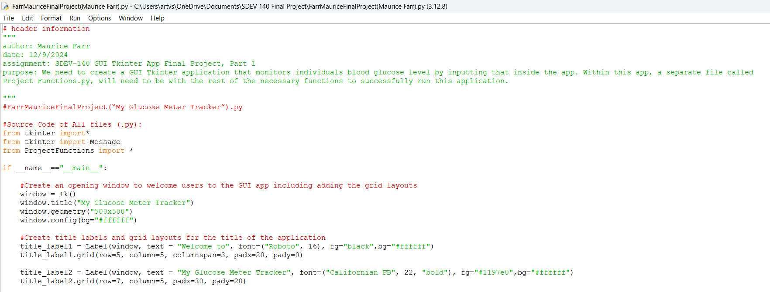

**Screenshot of Source Code of All Files #2:**

